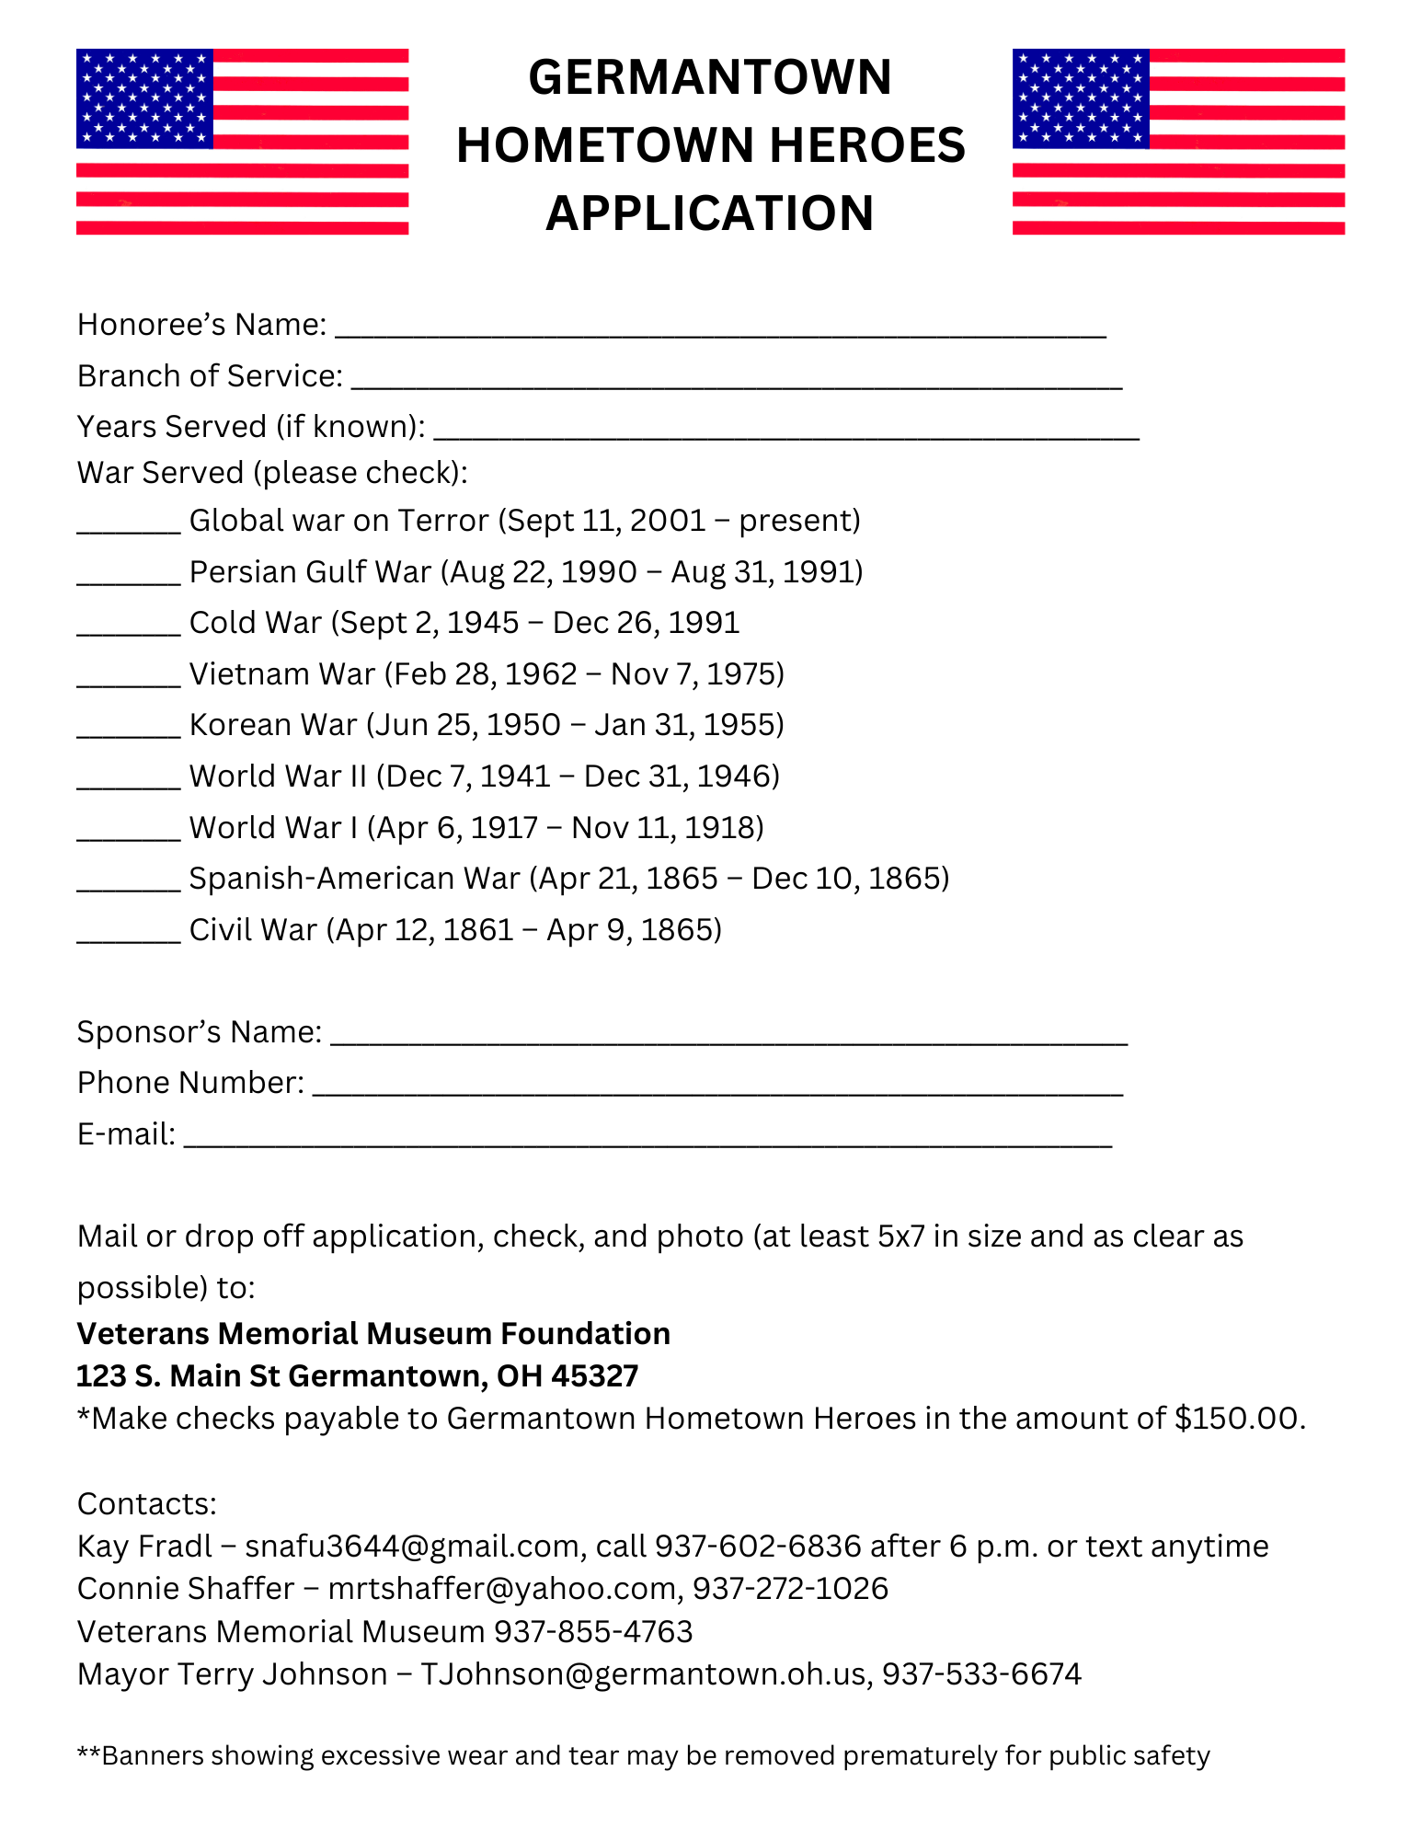

Due by **February 25th** to be up for 2025 and 2026!